**Eloise Wall Mount**

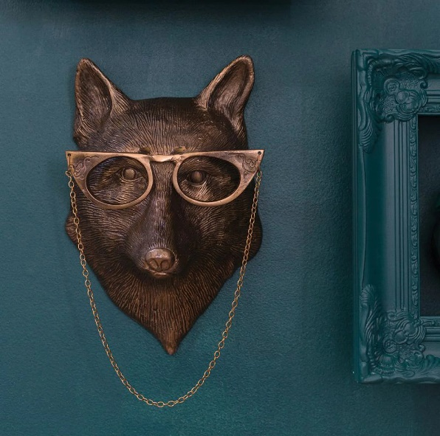The Eloise Wall Mount is a refined and stylish decorative piece that combines elegance with nature-inspired design. Featuring a beautifully crafted animal head or bird, the Eloise mount is often characterized by its graceful detailing, smooth textures, and timeless aesthetic. The design exudes a sense of sophistication, making it a perfect addition to both modern and classic interiors. With its high-quality craftsmanship and artistic appeal, the Eloise Wall Mount is ideal for those seeking a unique, eye-catching focal point that adds personality and charm to any room.